PRACTICA MENSAJERIA

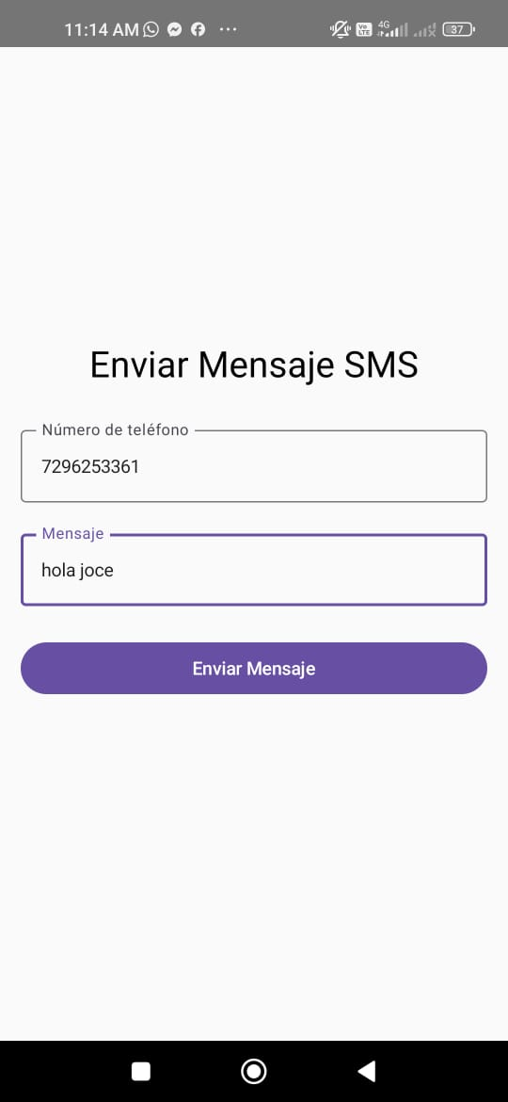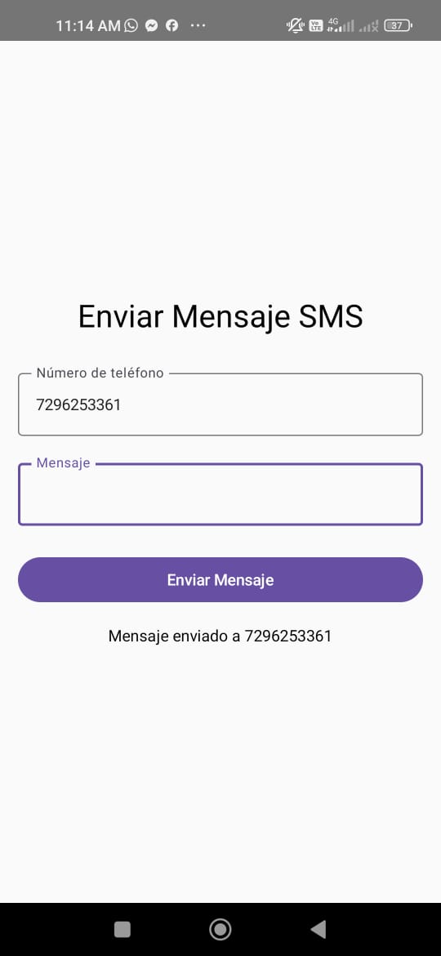

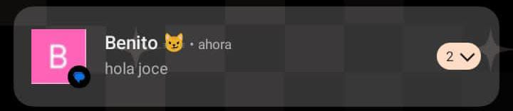

**AndroidManifest**

<?xml version="1.0" encoding="utf-8"?>  
<manifest xmlns:android="http://schemas.android.com/apk/res/android"  
 xmlns:tools="http://schemas.android.com/tools">  
  
 <uses-permission android:name="android.permission.SEND_SMS" />  
 <uses-permission android:name="android.permission.READ_PHONE_STATE" />  
  
 <application  
 android:allowBackup="true"  
 android:dataExtractionRules="@xml/data_extraction_rules"  
 android:fullBackupContent="@xml/backup_rules"  
 android:icon="@mipmap/ic_launcher"  
 android:label="@string/app_name"  
 android:roundIcon="@mipmap/ic_launcher_round"  
 android:supportsRtl="true"  
 android:theme="@style/Theme.Mensajes2">  
 <activity  
 android:name=".MainActivity"  
 android:exported="true"  
 android:label="@string/app_name"  
 android:theme="@style/Theme.Mensajes2">  
 <intent-filter>  
 <action android:name="android.intent.action.MAIN" />  
  
 <category android:name="android.intent.category.LAUNCHER" />  
 </intent-filter>  
 </activity>  
 </application>  
  
</manifest>

**MainActivity**

package com.tesji.mensajes2  
import android.content.pm.PackageManager  
import android.os.Bundle  
import android.telephony.SmsManager  
import androidx.activity.ComponentActivity  
import androidx.activity.compose.setContent  
import androidx.compose.foundation.layout.*  
import androidx.compose.material3.*  
import androidx.compose.runtime.*  
  
import androidx.compose.ui.Alignment  
import androidx.compose.ui.Modifier  
import androidx.compose.ui.platform.LocalContext  
import androidx.compose.ui.unit.dp  
import androidx.core.app.ActivityCompat  
import androidx.core.content.ContextCompat  
  
class MainActivity : ComponentActivity() {  
 override fun onCreate(savedInstanceState: Bundle?) {  
 super.onCreate(savedInstanceState)  
 *setContent* **{** MessageApp()  
 **}** }  
}  
  
@OptIn(ExperimentalMaterial3Api::class)  
@Composable  
fun MessageApp() {  
 var phoneNumber by remember **{** mutableStateOf("") **}** var messageText by remember **{** mutableStateOf("") **}** var status by remember **{** mutableStateOf("") **}** val context = LocalContext.current  
  
 Column(  
 modifier = Modifier  
 .fillMaxSize()  
 .padding(16.dp),  
 verticalArrangement = Arrangement.Center,  
  
 horizontalAlignment = Alignment.CenterHorizontally  
 ) **{** Text(  
 text = "Enviar Mensaje SMS",  
 style = MaterialTheme.typography.headlineMedium  
 )  
  
 Spacer(modifier = Modifier.height(24.dp))  
  
 OutlinedTextField(  
 value = phoneNumber,  
 onValueChange = **{** phoneNumber = it **}**,  
 label = **{** Text("Número de teléfono") **}**,  
 modifier = Modifier.fillMaxWidth()  
 )  
  
 Spacer(modifier = Modifier.height(16.dp))  
  
 OutlinedTextField(  
 value = messageText,  
 onValueChange = **{** messageText = it **}**,  
 label = **{** Text("Mensaje") **}**,  
 modifier = Modifier.fillMaxWidth(),  
 maxLines = 3  
 )  
  
 Spacer(modifier = Modifier.height(24.dp))  
  
 Button(  
  
 onClick = **{** if (phoneNumber.isBlank() || messageText.isBlank()) {  
 status = "Número o mensaje vacío"  
 return@Button  
 }  
  
// Verificar permisos  
 if (ContextCompat.checkSelfPermission(  
 context,  
 android.Manifest.permission.SEND_SMS  
 ) != PackageManager.PERMISSION_GRANTED  
 ) {  
 status = "Se necesita permiso para enviar SMS"  
 ActivityCompat.requestPermissions(  
 context as ComponentActivity,  
 arrayOf(android.Manifest.permission.SEND_SMS),  
 123  
 )  
 return@Button  
 }  
  
// Enviar el mensaje  
 try {  
 val smsManager: SmsManager = SmsManager.getDefault()  
 smsManager.sendTextMessage(  
 phoneNumber,  
 null,  
 messageText,  
 null,  
  
 null  
 )  
 status = "Mensaje enviado a $phoneNumber"  
 messageText = ""  
 } catch (e: Exception) {  
 status = "Error al enviar: ${e.message}"  
 }  
 **}**,  
 modifier = Modifier.fillMaxWidth()  
 ) **{** Text("Enviar Mensaje")  
 **}** Spacer(modifier = Modifier.height(16.dp))  
  
 Text(  
 text = status,  
 style = MaterialTheme.typography.bodyMedium  
 )  
 **}**}